**Follow these 8 easy steps below…**

**1: First select the language that you will translate to, click on the language.**

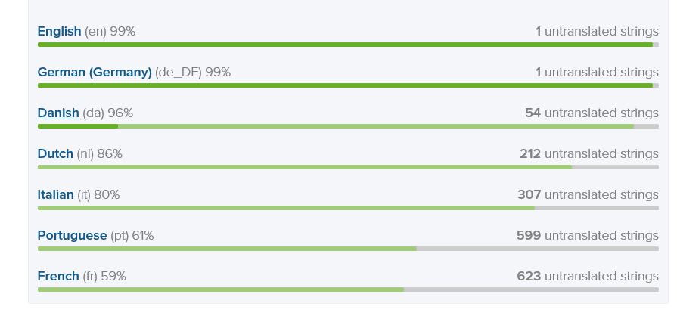

**2 : If you came from the wiki on Admidio’s homepage, this step is skipped. Goto step 3, otherwise if you see the Admidio folder just click on it.**

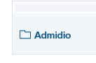

**3: Select for example, “main program strings”, click on that line**



**4: On the pop-up window that pops up, click the button “Translate”**

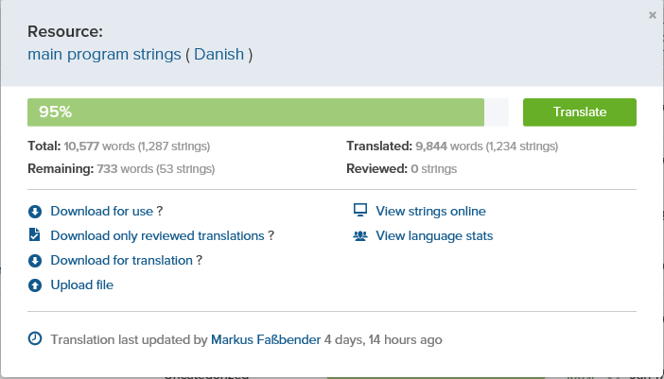

**Continued on the next page**

**5: Click on the “Settings” icon, in the top right corner of the webpage.**

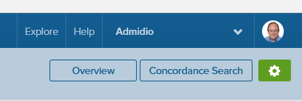

**6: Select “Show source string in German”**

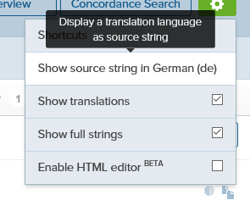

**7: This will bring up another pop-up window.**

**Click the little scrolldown menu arrow, now you can select which “source language” you want, you SHOULD base your translation on the ENGLISH (en) language file.**

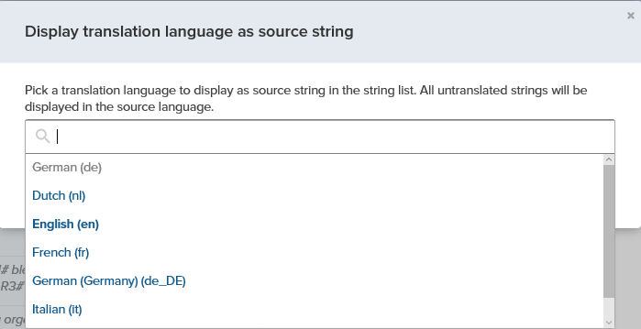

**8: Now when you have selected the English (en), click the button, Set language, and you’re done!**

